(Approx. 1402 words)

President's Corner
Taking Technology Too Personally
By Greg Skalka, President, Under the Computer Hood Users Group
https://www.uchug.org
president (at) uchug.org

When I was growing up, there seemed to be more universal and unifying experiences in our lives related to technology. We had much less tech than today, but it served us well and was more common in its applications and experiences. While there were the 'have' and 'have not' divides initially, new devices were often adopted relatively quickly and usually went to fairly high usage levels across society. This provided a common basis of experience for most people.

Television often provided a common topic that many strangers could discuss. With few channels and limited programming, a large number of people were watching the same things. You could talk to your friends about the shows you watched the night before as they likely watched some of the same ones. Telephones were very basic but provided a capability that everyone had to have. The instruments were all very similar as Ma Bell controlled the technology and the market. The rotary dial of the phone and the channel knob on the TV provided simple, common user interfaces. Anyone versed in using a phone or TV set could likely operate anyone's phone or TV. Operating a car was the same; with its standardized controls, almost anyone could drive any vehicle (even use most of the accessories). Our homes had very standardized appliances and lighting systems, providing a common user experience.

Today we have much more technology, much more complex technology, and more diverse technology. In addition to more capabilities, we have more choices, with more competition in the marketplace. As a result, there is much less standardization and much more personalization. Choice can be good, but with more options, there is often less consensus. There are more ways to personalize your experiences, which means fewer people use the same things, watch the same things or do the same things. This can result in fewer people caring about the same things as you do. While our technology supposedly enables greater communication, the countless choices, versions, and variations we have can sometimes be an isolating factor in society.

It is great to have thousands of choices of what to watch on television, but having a shared cultural baseline is more difficult when everyone watches something different. Choices don't end with content; how you watch can be personal. Fewer people watch "broadcast" television (over the air); we often choose cable, satellite, or streaming. Music is consumed in the same ways with the same multitude of choices. If you don't like what is playing, tell Alexa to skip to the next song. More and more, our entertainment is "on demand." At one time, we more often watched shows or listened to music with others; now, we are more likely to consume media individually. Instead of getting together to listen to that new album, we have our own playlists.

The introduction of the "personal" computer may not have started the trend, but it seemed to accelerate it. First, families used to sit around the radio in the evenings for entertainment; later, the focal point was the living room television. The personal computer pushed everyone to their own devices. I remember having four computers in our house when our two children lived with us. There are only two of us here, but we do have more than four computers in the house.

Smartphones are the ultimate in "personal" devices. Almost everyone has one. They are not the same. However, they could be iPhone or Android, and any number of makes, models, and screen sizes. Even the same phones can be loaded with personalized apps, photos, media, and cases. Unfortunately, no one shares them, so everyone is alone with their individualized device. I've seen this sad scene far too many times: a family out at a restaurant, and each member, while sitting together, is intently manipulating their own smartphone. And they don't appear to be communicating with each other.

There are now so many choices in the tech world and so few standards. Email used to be pretty standardized. Remember the AOL voice saying, "You've got mail." It was once so culturally universal that it was the title of a movie. Now there are so many email clients, web hosts, and types of devices to get mail on that everyone's email experience can be unique. I don't know if that is good or bad, but it is the direction most things are going. It is probably not hard to name five different ways of doing anything, from listening to a podcast, viewing a movie, placing a voice call, or writing a document.

Tech companies are just giving us what we want. More choices, more things we "need," more opportunities to buy their products and services. While there can be dominant providers in the market, being dominant does not necessarily make them the best. With so many things to have and so many choices for each, how can anyone optimize their lives? What is the best photo editor? The best streaming service? The best smartphone? The best family car? The best internet provider? These are hard questions to answer as they are. When you add "for me" to the end of each, it gets even more complicated. Do you spend so much time researching your choices that you never get to enjoy your things? By the time you have finished your research, is the item you chose out of date? Do you pick what your friends are using or what you have seen in commercials? Do you keep a suboptimal service because it is a hassle to change?

Our technology is much more powerful but also much more complex. At one time, you simply had to turn on the TV power switch to watch something. Now you may also have to select a signal source, app, or service, using a remote control with dozens of buttons on it. For example, to drive a car, you unlocked the door, put the key in the ignition switch, turned it, put the transmission in gear, and drove. Now you may have a remote fob to unlock it, you may press a button on the dash to start it (assuming the fob is near), and the pedal you press may inject more fuel into an internal combustion engine or may provide more current from a battery to an electric motor. Finally, one day you may get in and tell the car where you want to go.

As our things become more and more complex, they sometimes don't do what we expect them to. Sometimes this is our fault, as we may not fully understand how to use them. For example, my parents have had to buy a new dishwasher and a new washing machine in the last year, and though the new items are more energy-efficient and do more things, they are more difficult for them to operate. They bought a Samsung dishwasher with the controls on the top edge (rather than the face) of the door. This is confusing even to me. On their old dishwasher, you closed the door and set the controls to run it. On this new one, you set it to run and then close the door, as the controls are inaccessible with the door closed. Their old clothes washer had a big knob on the panel to control it; the new one has buttons to move LED indicators to set modes. It does more but is more challenging to figure out how to set.

Other times, our devices are so complex that they don't operate in a stable and consistent manner. Unfortunately, with our internet-connected devices, that which works today may not work the same tomorrow, as updates change features, fix bugs, and introduce new bugs. We have a lot of smart home devices in our house, including various Amazon Echo smart speakers and internet-connected light controllers of different brands and styles. I've been using the light device apps to turn on lights at certain times in the morning and then turn them off manually with our Echo Show in the kitchen. Recently I've been having problems controlling the lights through the Echo Show reliably. My wife uses the Show as a timer for cooking. Recently she has been setting timers, but the alarm never goes off. It seems like the Show got a bad update.

With all the choices and options available, tech means something different to each of us. We can tailor our devices and services to our preferences for experiences that are uniquely ours. However, if our devices don't act the way we want them to, it is not clear who is to blame or who will sympathize.

Ice Inside
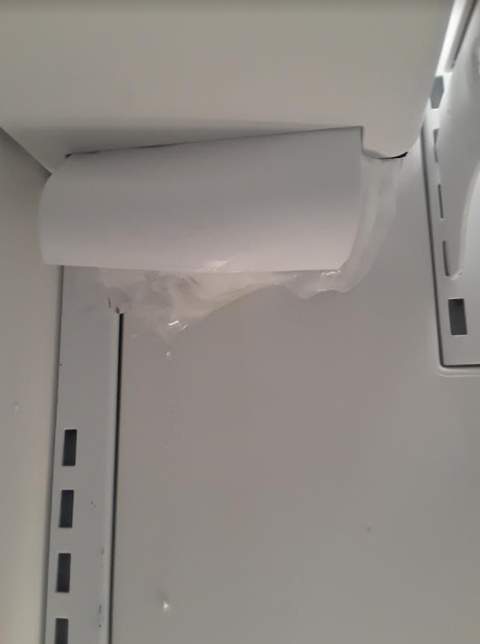

Refrigerator rear ice
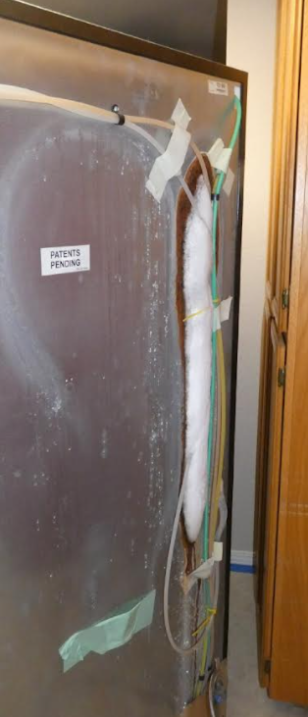

Refrigerator blanket
